**3) Demographic Trends Analysis**

USE world_bank_data;

-- RETRIEVE Population growth by country

SELECT country, date, population_growth

FROM demographic_indicators

ORDER BY country, date;

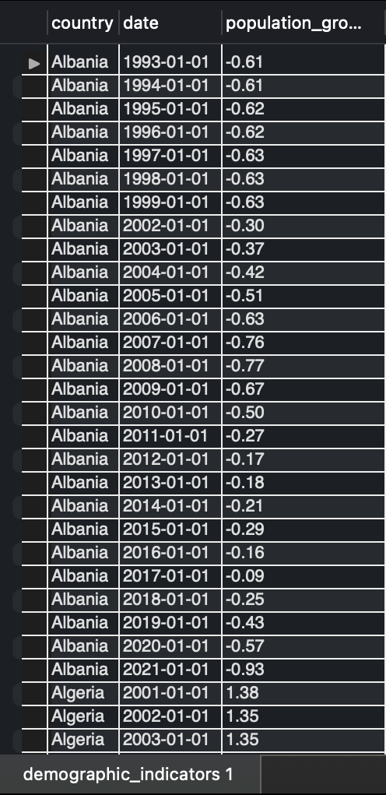

**Explanation:** This query retrieves population_growth for each country ordered by country and date. It helps observe the changes in population growth over time for each country.

-- Top 10 Countries by Life Expectancy

SELECT country, life_expectancy

FROM demographic_indicators

WHERE date = (SELECT MAX(date) FROM demographic_indicators)

ORDER BY life_expectancy DESC

LIMIT 10;

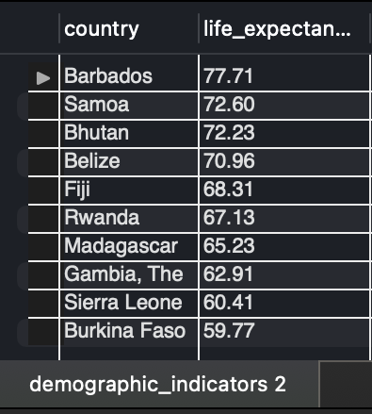

**Explanation:** This query lists the top 10 countries with the highest life expectancy based on the most recent data available, providing insight into countries with the longest life expectancies.

-- Average Child Mortality rate by region

SELECT region, AVG(child_mortality_rate) AS avg_child_mortality

FROM demographic_indicators

JOIN locations ON demographic_indicators.location_id = locations.location_id

GROUP BY region

ORDER BY avg_child_mortality;

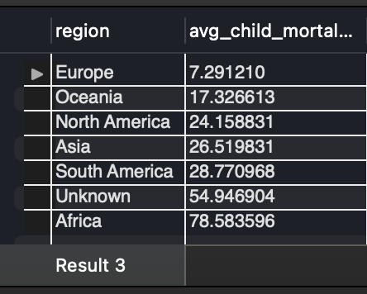

**Explanation:** Calculates the average child mortality rate for each region, allowing comparison across regions. Lower values indicate better child survival rates, often reflecting better healthcare and living conditions.

-- Population trend over time for Albania

SELECT date, population_total

FROM demographic_indicators

WHERE country = 'Albania'

ORDER BY date;

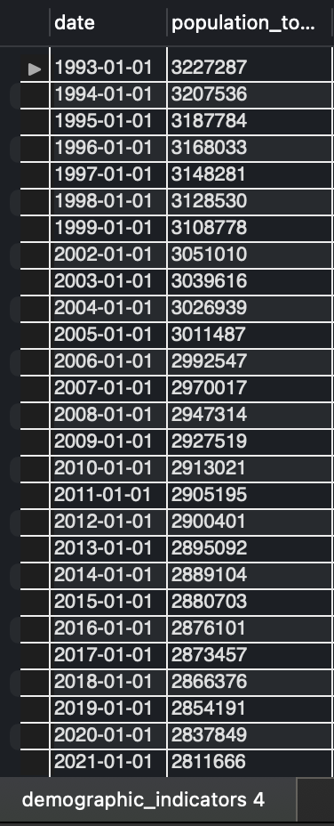

**Explanation:** Retrieves population totals over time for Albania. This trend analysis shows how the population has changed, which can be useful for understanding demographic shifts within the country.

-- Countries with the highest urban population percentage

SELECT country, urban_population

FROM demographic_indicators

WHERE date = (SELECT MAX(date) FROM demographic_indicators)

ORDER BY urban_population DESC

LIMIT 10;

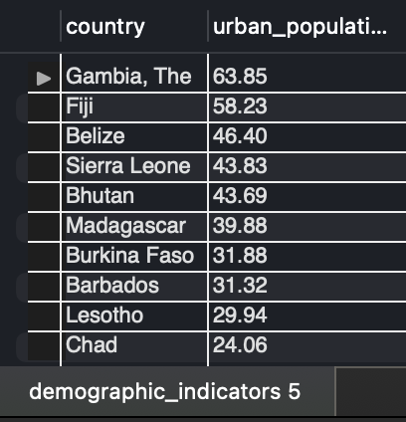

**Explanation:** Lists the top 10 countries with the highest percentage of the population living in urban areas based on the lates data. This highlights countries with high urbanization, which can correlate with industrialization and economic development.

-- View 1: for population growth by country

CREATE VIEW PopulationGrowthByCountry AS

SELECT country, date, population_growth

FROM demographic_indicators

ORDER BY country, date;

-- Query this view

SELECT * FROM PopulationGrowthByCountry WHERE country = 'Brazil';

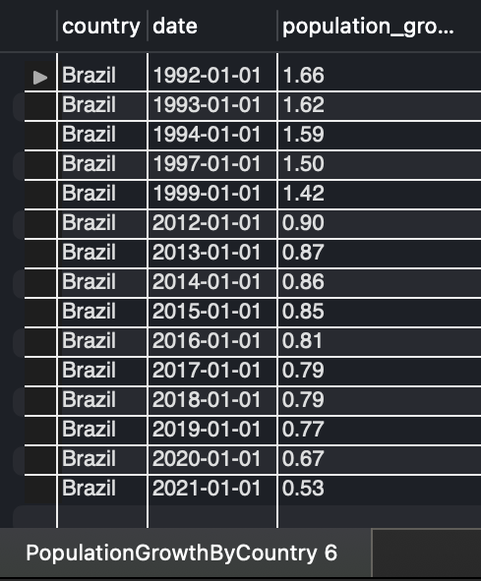

**Explanation:** Creates a view for population growth by country, making it easy to access this data without rewriting the query.

-- View 2: for average life expectancy by region

CREATE VIEW AvgLifeExpectancyByRegion AS

SELECT region, AVG(life_expectancy) AS avg_life_expectancy

FROM demographic_indicators

JOIN locations ON demographic_indicators.location_id = locations.location_id

GROUP BY region;

-- Query this view

SELECT * FROM AvgLifeExpectancyByRegion;

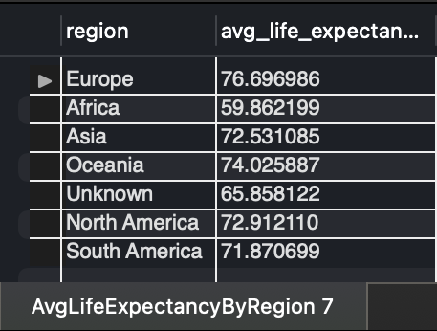

**Explanation:** Averages life expectancy by region, providing insights into overall health and longevity by region.

-- View 3: child mortality by year for a specific country

CREATE VIEW ChildMortalityByCountry AS

SELECT country, YEAR(date) AS year, AVG(child_mortality_rate) AS avg_child_mortality

FROM demographic_indicators

GROUP BY country, year;

-- Query this view

SELECT * FROM ChildMortalityByCountry WHERE country = 'Chad';

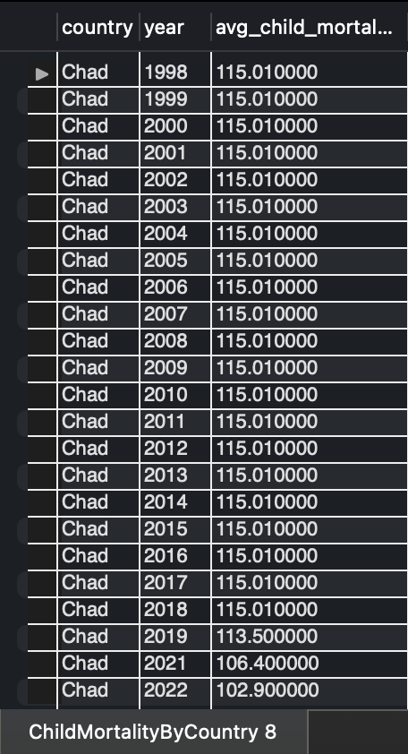

**Explanation:** This view captures average child mortality rates by year for each country, allowing for trend analysis in child mortality over time.

-- Stored Procedure 1: to retrieve life expectancy trends for a country

DELIMITER //

CREATE PROCEDURE GetLifeExpectancyByCountry(IN country_name VARCHAR(50))

BEGIN

SELECT date, life_expectancy

FROM demographic_indicators

WHERE country = country_name

ORDER BY date;

END //

DELIMITER ;

-- Call this procedure

CALL GetLifeExpectancyByCountry('India');

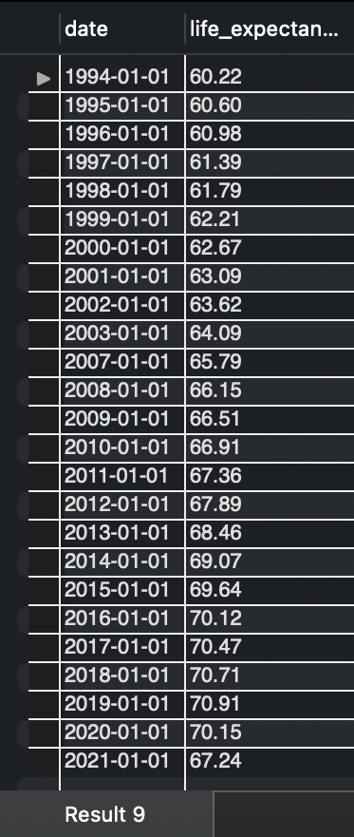

**Explanation:** This procedure returns life expectancy trends over time for a specified country, helping analyze changes in life expectancy.

-- Stored Procedure 2: to get average population growth for a region

DELIMITER //

CREATE PROCEDURE GetAvgPopulationGrowthByRegion(IN region_name VARCHAR(50))

BEGIN

SELECT region, AVG(population_growth) AS avg_population_growth

FROM demographic_indicators

JOIN locations ON demographic_indicators.location_id = locations.location_id

WHERE region = region_name

GROUP BY region;

END //

DELIMITER ;

-- Call this procedure

CALL GetAvgPopulationGrowthByRegion('Asia');

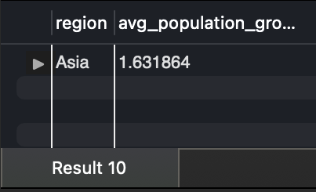

**Explanation:** This procedure calculates the average population growth for a specified region, which is useful for understanding demographic trends by region.

-- Function 1: to calculate average life expectancy for a country

DELIMITER //

CREATE FUNCTION GetAvgLifeExpectancy(country_name VARCHAR(50))

RETURNS DECIMAL(5,2)

DETERMINISTIC

BEGIN

DECLARE avg_life_exp DECIMAL(5,2);

SELECT AVG(life_expectancy) INTO avg_life_exp

FROM demographic_indicators

WHERE country = country_name

LIMIT 1;

RETURN avg_life_exp;

END //

DELIMITER ;

-- Use this function

SELECT GetAvgLifeExpectancy('Germany');

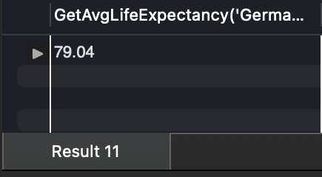

**Explanation:** This function returns the average life expectancy for a specified country, providing a summary measure of health and longevity.

-- Function 2: to get child mortality rate for a specific year and country

DELIMITER //

CREATE FUNCTION GetChildMortality(country_name VARCHAR(50), year_val INT)

RETURNS DECIMAL(5,2)

DETERMINISTIC

BEGIN

DECLARE mortality_rate DECIMAL(5,2);

SELECT child_mortality_rate INTO mortality_rate

FROM demographic_indicators

WHERE country = country_name AND YEAR(date) = year_val

LIMIT 1;

RETURN mortality_rate;

END //

DELIMITER ;

-- Use this function

SELECT GetChildMortality('Burkina Faso', 2018);

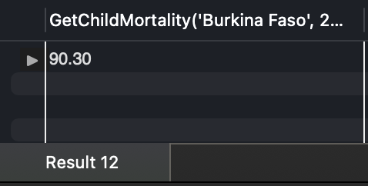

**Explanation:** This function retrieves the child mortality rate for a specified country and year, offering insight into child survival rates for that period.